Individual Project Final Submission Report

Prepared By: Harsha vardan Date Prepared: 12/7/25
Status: Approved, Completed Version: Final
.

Problem Statement

Business Problem statement | Employee Management, Attendance Tracking, and Performance Monitoring System
Description of the problem addressed | Many organizations face difficulties in managing employee master data, tracking daily attendance, recording overtime hours, and monitoring employee performance using a single unified system. In most cases, this information is maintained manually or across separate systems, which leads to errors, data inconsistency, and inefficiencies in reporting.  The business problem addressed in this project is the lack of a centralized automated SAP-based solution that allows:  - Quick maintenance of employee master records  - Easy entry of attendance data  - View and analysis of employee attendance, overtime, and performance  - Real-time updating of employee status  This project was designed and developed as an integrated Employee Management Dashboard using ABAP Module Pool and SE38 reports to solve these issues and  improve operational efficiency.
Agreed Upon complexity | High Complexity  This project includes:  - Multiple 4 custom transparent tables  - Custom domains and data elements  - 2 SE38 reports for Employee Report and Employee Analytics  - A Module Pool program for Dashboard and Attendance Entry  - Table updates using UPDATE and INSERT statements  - Data retrieval using SELECT  - Integration between Module Pool and reports using SUBMIT
Scope | FUNCTIONS INSIDE THE SCOPE:  The following features are included in the scope of this project:

- Creation and maintenance of Employee Master Data
- Searching employee details using Employee ID
- Updating employee status from the Dashboard
- Attendance entry using a custom screen (Screen 200)
- Saving attendance data into table Z104_ATTENDANCE
- Displaying Employee Report using Z104_EMPLOYEE_REPORT
- Running Employee Analytics using Z104_EMP_ANALYTICS
- Data storage for:
  - Attendance (Z104_ATTENDANCE)
  - Overtime (Z104_EMP_OT)
  - Performance (Z104_EMP_PERF)
- Navigation between screens using pushbuttons
- F4 help for date selection

Functions OUTSIDE the Scope

The following features are not included in this system:

- Payroll processing
- Salary calculation
- Leave management
- Shift scheduling

Design Documentation

Functional Description | This project is designed as a custom Employee Management System in SAP using ABAP Module Pool programming and SE38 reports. The system allows users to maintain employee information, update employee status, enter daily attendance, and generate different types of employee reports. The application uses custom tables and provides a user-friendly dashboard interface for all major operations.  The central idea of the system is to provide a single interactive dashboard from where the user can perform the following functions:  - Search employee details  - Update employee status  - Enter employee attendance  - View employee master report  - View employee analytics report  Functional Modules Used in the System

The system consists of three main functional components:

- Employee Master Management
- Attendance Management
- Employee Reporting and Analytics

Each of these modules is integrated through the Module Pool Dashboard Program.
- Employee Master Management – Functional Flow
Table Used

Z104_EMP_MASTER

Main Purpose

This table stores the core employee details such as:

  - Employee ID
  - Employee Name
  - Organization Unit
  - Designation
  - Status

Screen Used

  - Screen 100 – Employee Dashboard
Functional Flow

- The user enters the Employee ID in the input field on Screen 100.
- When the user clicks the Search button:
  - The system executes a SELECT SINGLE statement on
Z104_EMP_MASTER.
  - If a record is found, employee details are displayed on the screen.
  - If no record is found, the system displays the message
“Employee not found.”
- The user can modify the Employee Status field.
- When the user clicks Update Status:
  - The system updates the status in the table Z104_EMP_MASTER
using the UPDATE statement.
  - A success or failure message is displayed based on the update result.

- Attendance Management – Functional Flow
Table Used

Z104_ATTENDANCE

Screen Used

Screen 200 – Attendance Entry
Main Purpose

This module allows the user to record daily attendance for employees.

Functional Flow

  - From Screen 100, the user clicks Mark Attendance.
  - The system navigates to Screen 200.
  - The user enters:
    - Employee ID
    - Attendance Date (using F4 calendar help)
    - Attendance Status (Present or Absent)
  - When the user clicks Save:
    - The system validates that all required fields are filled.
    - The system inserts a new record into the Z104_ATTENDANCE
table using the INSERT statement.
    - A success message is displayed if the record is saved successfully.
  - When the user clicks Back:
    - The system returns to Screen 100 (Dashboard).
This ensures that employee attendance is captured and stored correctly in the database.
- Employee Reporting and Analytics – Functional Flow
SE38 Programs Used

  - Z104_EMPLOYEE_REPORT
  - Z104_EMP_ANALYTICS
A. Employee Master Report (Z104_EMPLOYEE_REPORT)

This program displays employee master data from the table

Z104_EMP_MASTER using an ALV report.
Functional Flow
- The user clicks Employee Report on Screen 100.
- The system calls the report using:
- SUBMIT Z104_EMPLOYEE_REPORT
- The program retrieves data using SELECT and displays it using
CL_SALV_TABLE.
B. Employee Analytics Report (Z104_EMP_ANALYTICS)
This program displays:
- Attendance Report
- Overtime Report
- Performance Report
Tables Used
- Z104_ATTENDANCE
- Z104_EMP_OT
- Z104_EMP_PERF
Functional Flow
- The user clicks Analytics Report on Screen 100.
- The system calls:
- SUBMIT Z104_EMP_ANALYTICS
- The user selects one option:
  - Attendance
  - Overtime
  - Performance
- Based on the selection:
  - The system fetches the corresponding table data.
  - Displays it in ALV format.
Module Pool Navigation Flow
Screen Purpose
0100 Employee Dashboard
0200 Attendance Entry
Navigation Buttons:

- Search

- Update Status
- Mark Attendance
- Employee Report
- Analytics Report
- Save
- Back
- Exit
Database Operations Used
Operation Purpose
SELECT Read employee and report data
INSERT Save attendance data
UPDATE Update employee status
SUBMIT Call SE38 reports
CALL SCREEN Navigate between screens LEAVE TO SCREEN Return to previous screen
Real-Time Processing

All operations are performed in real time, and changes made through Screen 100 and Screen 200 are immediately reflected in the database tables and the generated reports.
New or Updated Items Included in the Project Development – Internal to SAP |  | Custom Tables (SE11)  - Z104_EMP_MASTER: Employee details (EMP_ID, EMP_NAME, ORG_UNIT, DESIGNATION, STATUS)  - Z104_ATTENDANCE: Attendance records (EMP_ID, ATT_DATE, STATUS)  - Z104_EMP_OT: Overtime records (EMP_ID, OT_DATE, OT_HOURS, OT_REASON)  - Z104_EMP_PERF: Performance records (EMP_ID, PERF_DATE, PERF_SCORE, RATING)
- Domains and Data Elements

  - Z104_EMP_ID_D → Z104_EMP_ID_E (Employee ID)
  - Z104_NAME_D → Z104_EMP_NAME_E (Employee Name)
  - Z104_DATE_D → Z104_DATE_E (Date)
  - Z104_STATUS_D → Z104_STATUS_E (Status)

- Z104_OT_HOURS_D → Z104_OT_HOURS_E (Overtime Hours)
- Z104_SCORE_D → Z104_SCORE_E (Performance Score)
- Module Pool Program

  - Program: Z104_EMP_DASHBOARD
  - Screens:
    - 0100: Employee Dashboard (Search, Update Status, Run Reports, Navigate to Attendance)
    - 0200: Attendance Entry (Enter Attendance, F4 Date, Save, Back)
  - Pushbuttons / Function Codes: SEARCH, UPDSTAT, ATTEND, EMPREP, ANALYT, SAVE, BACK, EXIT
- SE38 Reports

  - Z104_EMPLOYEE_REPORT: Displays employee master data (ALV format)
  - Z104_EMP_ANALYTICS: Shows Attendance, Overtime, Performance reports (ALV format, radio button selection)
- Transaction Code

  - Z104_DASH → Launches Z104_EMP_DASHBOARD (Screen
0100)
- Table Updates

  - Attendance inserted into Z104_ATTENDANCE
  - Employee status updated in Z104_EMP_MASTER
New or Updated Items Included in the Project Development – External to SAP |  | User Screens  The system include program Z104_EM  Screen | s two main screens developed in the Module Pool  P_DASHBOARD:  Purpose
 |  | 0100 – Employee Dashboard | Central navigation for searching employees, updating status, launching reports, and marking attendance

0200 – Attendance Enter attendance details, select date with F4 help, and save Entry data to database
2. Reports (SE38)

The project includes two custom SAP reports:

Program Purpose Output Format
Z104_EMPLOYEE_REPORT Displays employee master details ALV Table
Displays Attendance, Overtime, and Z104_EMP_ANALYTICS Performance reports based on radio button ALV Table
selection

Reports are external to the Module Pool but integrated via SUBMIT
commands from the dashboard screen.
- Transaction Code

  - Z104_DASH
Allows external users to launch the Module Pool program directly from SAP menu.
- User Interactions

  - Users can select dates using F4 calendar.
  - Click pushbuttons to perform operations such as Save, Back, Search, Update, Run Report
  - ALV reports are displayed in tabular format for clarity and external consumption
- Output / Interfaces

  - ALV tables provide external users with readable, structured data
  - Messages displayed on the screen indicate success/failure of updates
  - Date selection with F4 ensures error-free input for attendance
Other

Development Documentation

Pseudocode |  | . Module Pool Program: Z104_EMP_DASHBOARD  Screen 100 – Employee Dashboard  - User enters Employee ID in input field (GV_EMPID).  - User clicks Search:  - The program performs SELECT SINGLE on table  Z104_EMP_MASTER for the given Employee ID.  - If found, the program populates:  - Employee Name (GV_NAME)  - Organization Unit (GV_ORG)  - Designation (GV_DESIG)  - Employee Status (GV_STATUS)  - If not found, a message “Employee not found” is displayed.  - User can change Employee Status (GV_STATUS) and click Update Status:  - The program performs an UPDATE on table  Z104_EMP_MASTER.  - Displays success/failure message.  - User clicks Mark Attendance:  - Program navigates to Screen 200 – Attendance Entry.  - User clicks Employee Report or Analytics Report:  - Program calls SUBMIT for:  - Z104_EMPLOYEE_REPORT  - Z104_EMP_ANALYTICS (Attendance, Overtime, Performance ALV reports)  - User clicks Exit:  - Program terminates.
Screen 200 – Attendance Entry

- Employee ID (GV_EMPID) is pre-filled from Dashboard.
- User selects Attendance Date (GV_ATT_DATE) using F4 calendar.
- User enters Attendance Status (GV_ATT_STAT).
- User clicks Save:
  - Program checks that all fields are filled.
  - Creates a work area (WA_ATT) and populates:
    - EMP_ID, ATT_DATE, STATUS
  - Inserts record into table Z104_ATTENDANCE.
  - Displays success or failure message.
- User clicks Back:

 |  | - Program returns to Screen 100 – Dashboard.
- SE38 Programs

Z104_EMPLOYEE_REPORT

  - Fetches all records from Z104_EMP_MASTER using SELECT.
  - Displays data in ALV table (CL_SALV_TABLE).
  - Provides read-only view for user.

Z104_EMP_ANALYTICS

  - User selects report type: Attendance / Overtime / Performance.
  - Based on selection:
    - Fetches data from Z104_ATTENDANCE, Z104_EMP_OT, or
Z104_EMP_PERF.
    - Displays in ALV table.
Design Documentation |  | Tables and Relationships  Table Key Fields Related Tables  Z104_EMP_MASTER EMP_ID Z104_ATTENDANCE, Z104_EMP_OT,  Z104_EMP_PERF  Z104_ATTENDANCE ATT_ID, EMP_ID Z104_EMP_MASTER  Z104_EMP_OT EMP_ID, Z104_EMP_MASTER  OT_DATE  Z104_EMP_PERF EMP_ID, Z104_EMP_MASTER  PERF_DATE  Relationships:  EMP_ID is the primary link between master, attendance, overtime, and performance tables.
2. Module Pool Screens
Screen Purpose Navigation
0100 Dashboard Central control for Calls reports, updates status, employee operations navigates to attendance
0200 Attendance Enter attendance Back to dashboard using Back Entry button
 |  | 3. Program Flow

Logical Step | SAP Object / Statement
Search employee | SELECT SINGLE * FROM Z104_EMP_MASTER
Update status | UPDATE Z104_EMP_MASTER SET STATUS = GV_STATUS
Insert attendance | INSERT Z104_ATTENDANCE FROM WA_ATT
Run Employee Report | SUBMIT Z104_EMPLOYEE_REPORT
Run Analytics Report | SUBMIT Z104_EMP_ANALYTICS
Navigate screens | CALL SCREEN 200 / LEAVE TO SCREEN 100
F4 Calendar | FIELD GV_ATT_DATE MODULE F4_DATE
ALV Display | CL_SALV_TABLE=>factory

Open Issues
- Module Pool handles screen navigation, database updates, and report submission.
- Reports (SE38) handle data display and analytics.
- Pushbuttons / Function Codes trigger operations (SEARCH,
UPDSTAT, SAVE, BACK, EMPREP, ANALYT, EXIT).
4. Pseudocode to Technical Mapping
Other

Open Issues | - Attendance Duplicate Entries  - Currently, the system does not prevent multiple attendance entries for the same employee on the same date.  - Example 1: If an employee “Harsha” is accidentally marked twice  on 2025-02-07, two records will exist in Z104_ATTENDANCE.  - Example 2: If an employee “Rahul” tries to mark attendance for the same date again, the system will allow it without warning, which may lead to inconsistent reporting.  - Suggested Improvement: Implement a check using SELECT SINGLE before INSERT to prevent duplicates.  - Limited Reporting and Analytics  - The system currently only displays ALV tables for Attendance, Overtime, and Performance.  - Example 1: Viewing attendance trends over a month requires manual aggregation from the table Z104_ATTENDANCE since no charts are provided.  - Example 2: Overtime analytics are only shown as a table in Z104_EMP_ANALYTICS report; graphical insights for performance comparisons are missing.  - Suggested Improvement: Incorporate ALV charts, trend lines, or

SAP Smartforms for better visualization.

Functional Design Assumptions

Assumptions |  | - Unique Employee IDs  - Every employee has a unique Employee ID (EMP_ID) in the  Z104_EMP_MASTER table.  - The system assumes no duplicate Employee IDs exist, as all search, update, and reporting functionalities rely on this unique identifier.  - Example: If two employees have the same EMP_ID, the system may fetch incorrect details, causing inaccurate updates or report outputs.  - Master Data is Pre-Existing  - Employee master data, including name, designation, organization unit, and initial status, must already exist in Z104_EMP_MASTER.  - The system assumes that only valid Employee IDs are entered during attendance, status updates, and reports.  - Example: Searching for an Employee ID not in the table will  result in a “Employee not found” message.
Attendance and Data Entry Assumptions

- Attendance Entries are Single-Day and Sequential
  - The system assumes each attendance record represents a single day and no duplicate entries exist for the same employee on the same date.
  - Users are expected to enter attendance manually, and the program does not automatically detect duplicates.
  - Example: Employee “Harsha” should only have one attendance record per day; multiple entries could cause analytics misrepresentation.
- Valid Input Values
  - Attendance status (GV_ATT_STAT) must be provided and should only include predefined valid values, such as P (Present) or A (Absent).
  - The system assumes that users will provide valid and consistent input; incorrect values may lead to inconsistent reporting.
  - Example: Entering “X” or leaving the field blank may
generate a mandatory field warning.
- Valid Dates

- Attendance date (GV_ATT_DATE) must be a valid calendar date.
- The system uses SAP’s F4 calendar help to ensure the date
format is correct (YYYYMMDD).
- Example: Users cannot manually enter invalid dates like 31- 02-2025.
Reporting and Analytics Assumptions

- Reports Reflect Only Stored Data
  - Analytics reports (Z104_EMP_ANALYTICS) and employee reports (Z104_EMPLOYEE_REPORT) rely entirely on data stored in Z104_EMP_MASTER, Z104_ATTENDANCE, Z104_EMP_OT, and Z104_EMP_PERF.
  - The system assumes that all relevant data is up-to-date and correctly entered.
  - Example: If overtime hours are not recorded in
Z104_EMP_OT, the report will show zero or no data.
- User Interaction Assumptions
  - Users will operate the dashboard (Screen 100) and attendance entry screen (Screen 200) sequentially, following the intended navigation flow.
  - The system assumes users will use pushbuttons for operations and will not directly manipulate database tables outside the program.
  - Example: Clicking Mark Attendance will correctly navigate to Screen 200 and pre-fill the Employee ID.
System Limitations Assumptions

- No Role-Based Authorization
  - The system assumes that only authorized users have access to the custom transaction code (Z104_DASH) to perform operations.
  - The project does not currently include SAP role-based security checks, so all users with access can perform all actions.
- No Bulk Data Uploads
  - All employee, attendance, overtime, and performance data entries are assumed to be manual.
  - The project does not include mass uploads or automated integrations with external systems.

Conclusion of Assumptions

These assumptions establish clear boundaries for system behavior and define how the Module Pool program, SE38 reports, and custom tables are expected to interact. They ensure that:

- Employee data is consistent and valid
- Attendance and performance data is accurate and properly linked
- Reports correctly reflect real-time information
- Users follow the designed workflow for the dashboard and attendance entry

Functional Flow Chart

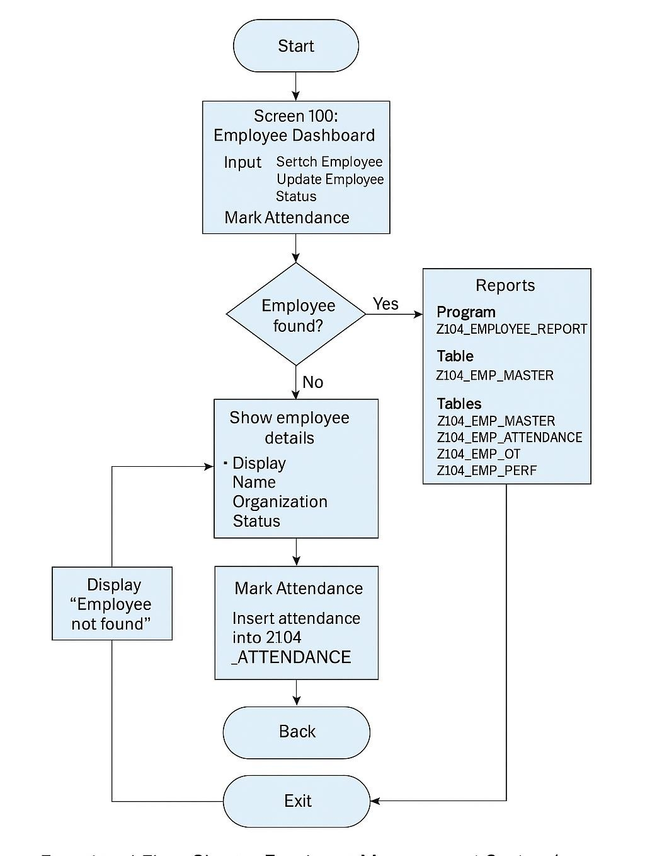

.

Additional information (OPTIONAL)

Other relevant information | Include anything else that you wish to share with the instructor. This is an  optional section created to accommodate the individual’s journey.

